When I connect the battery a cable starts smoking
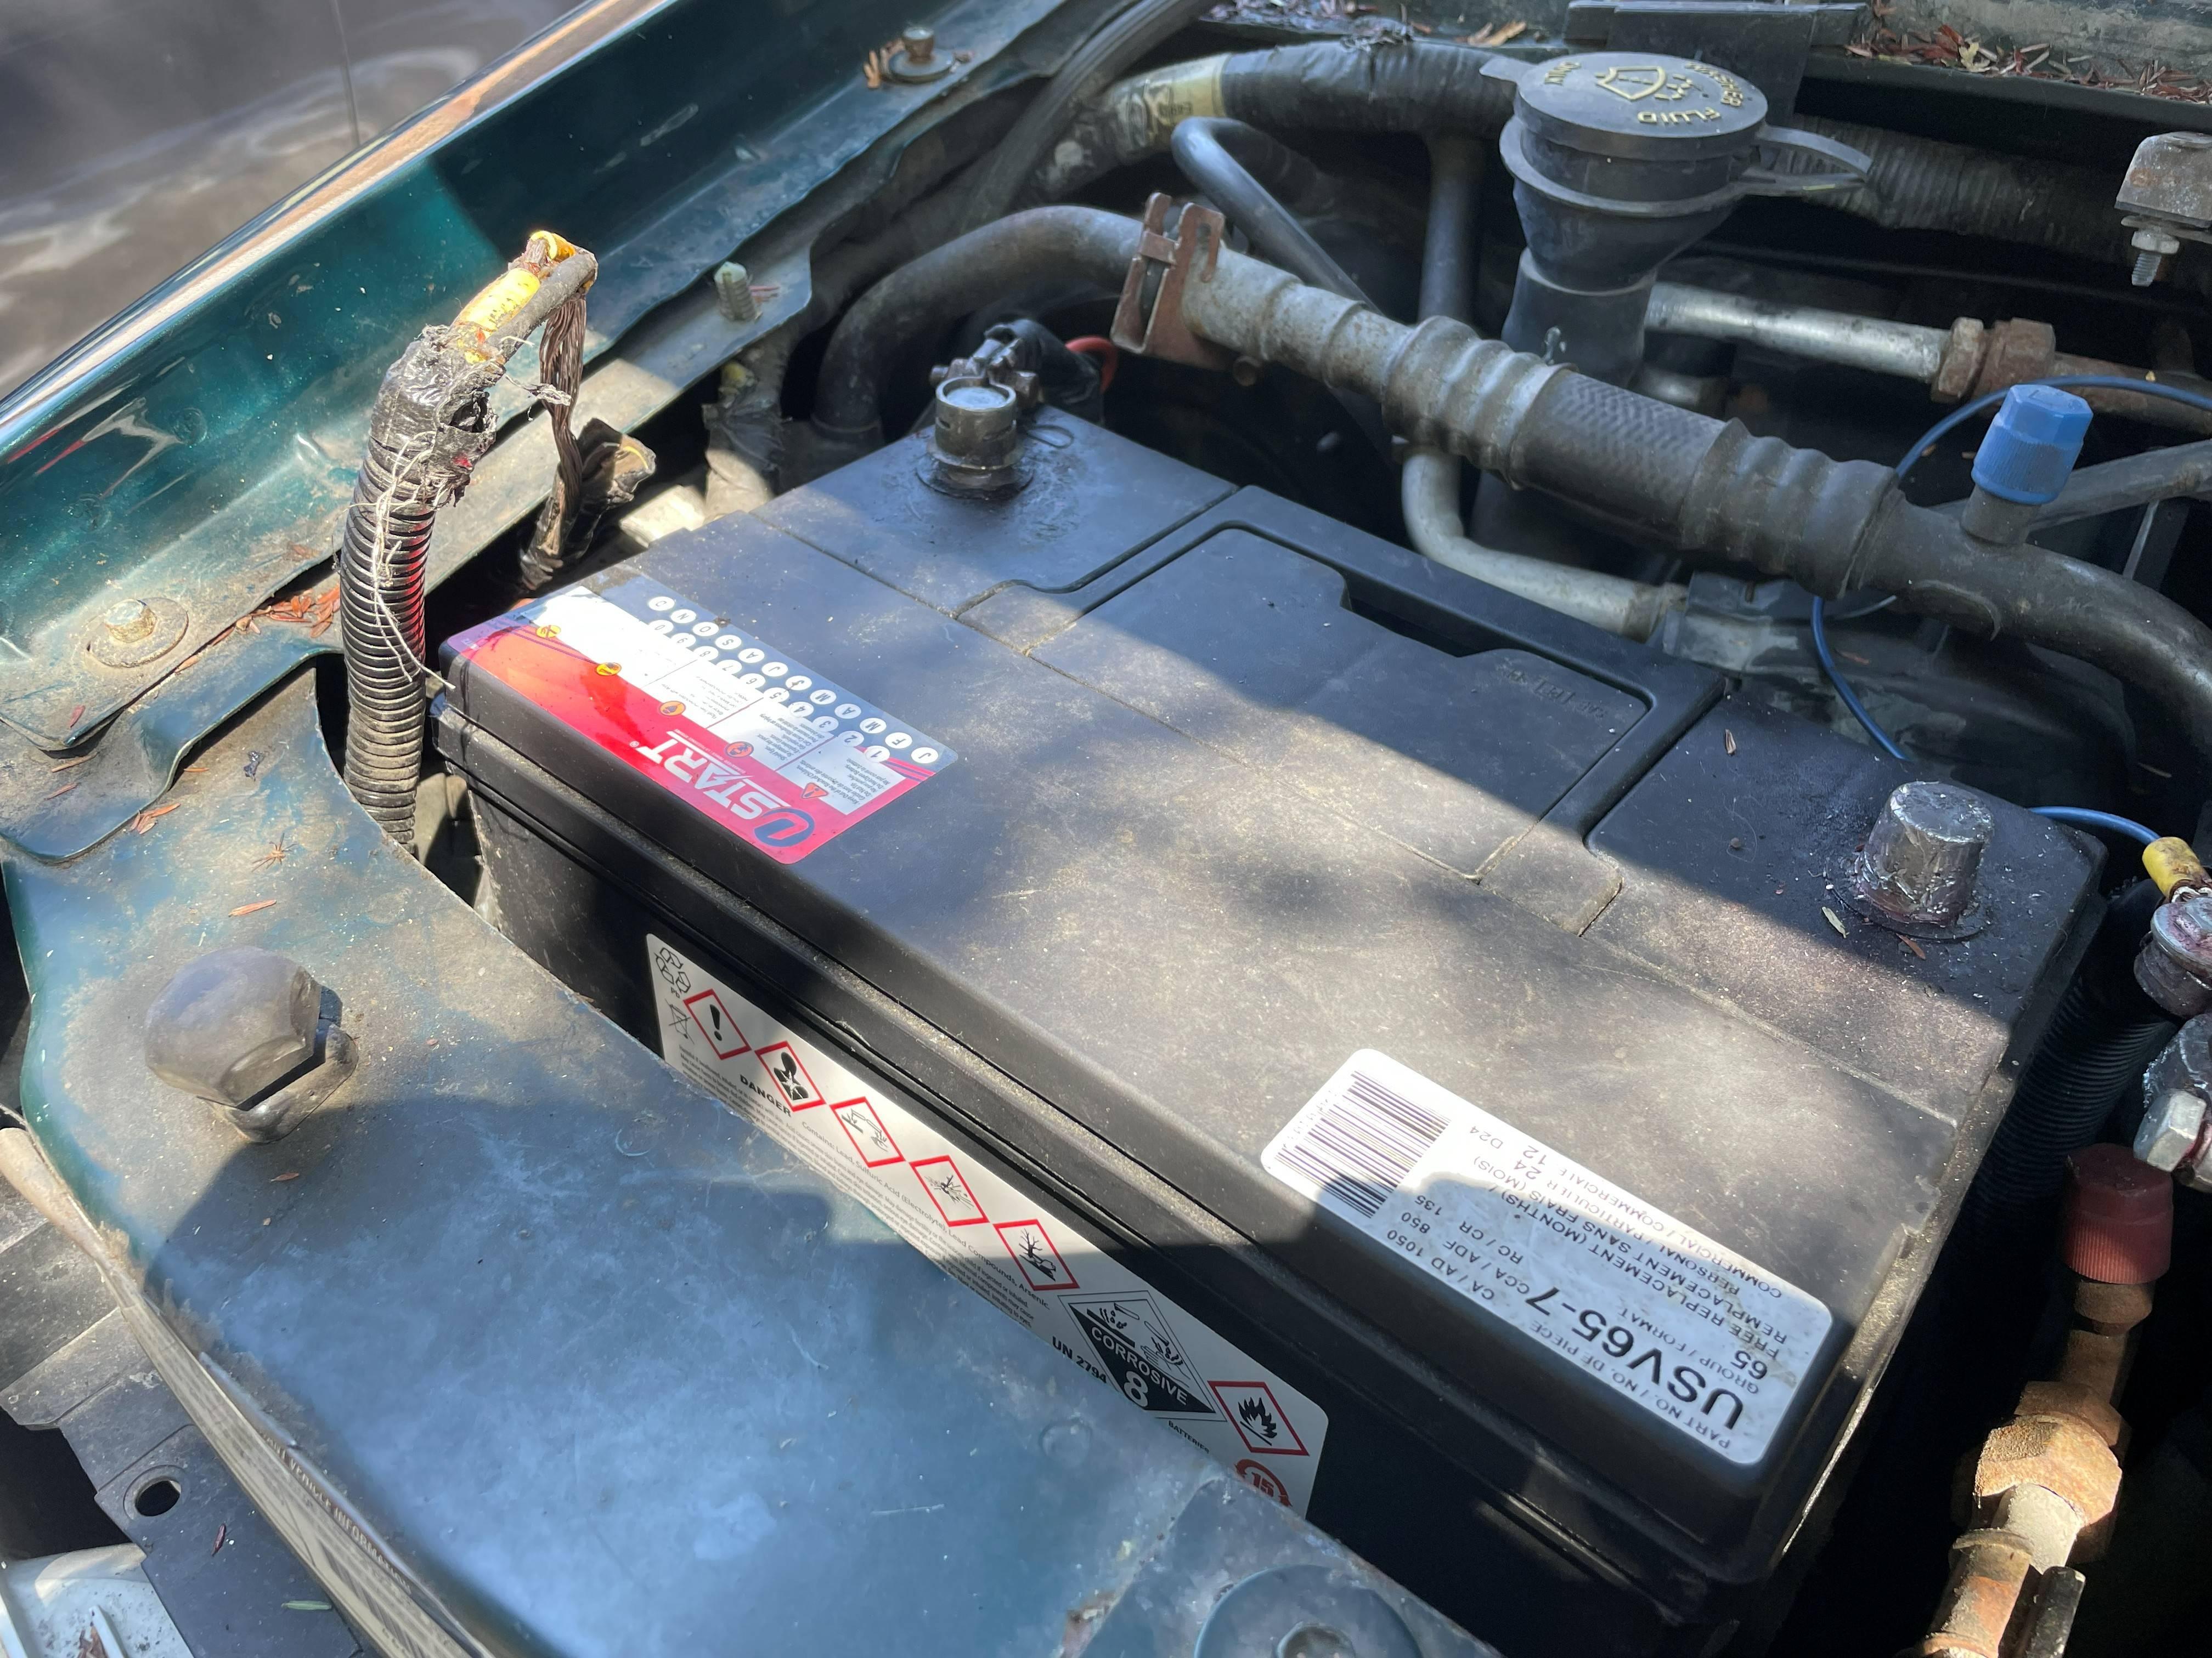
This cable

I took the battery out and traced the cable:
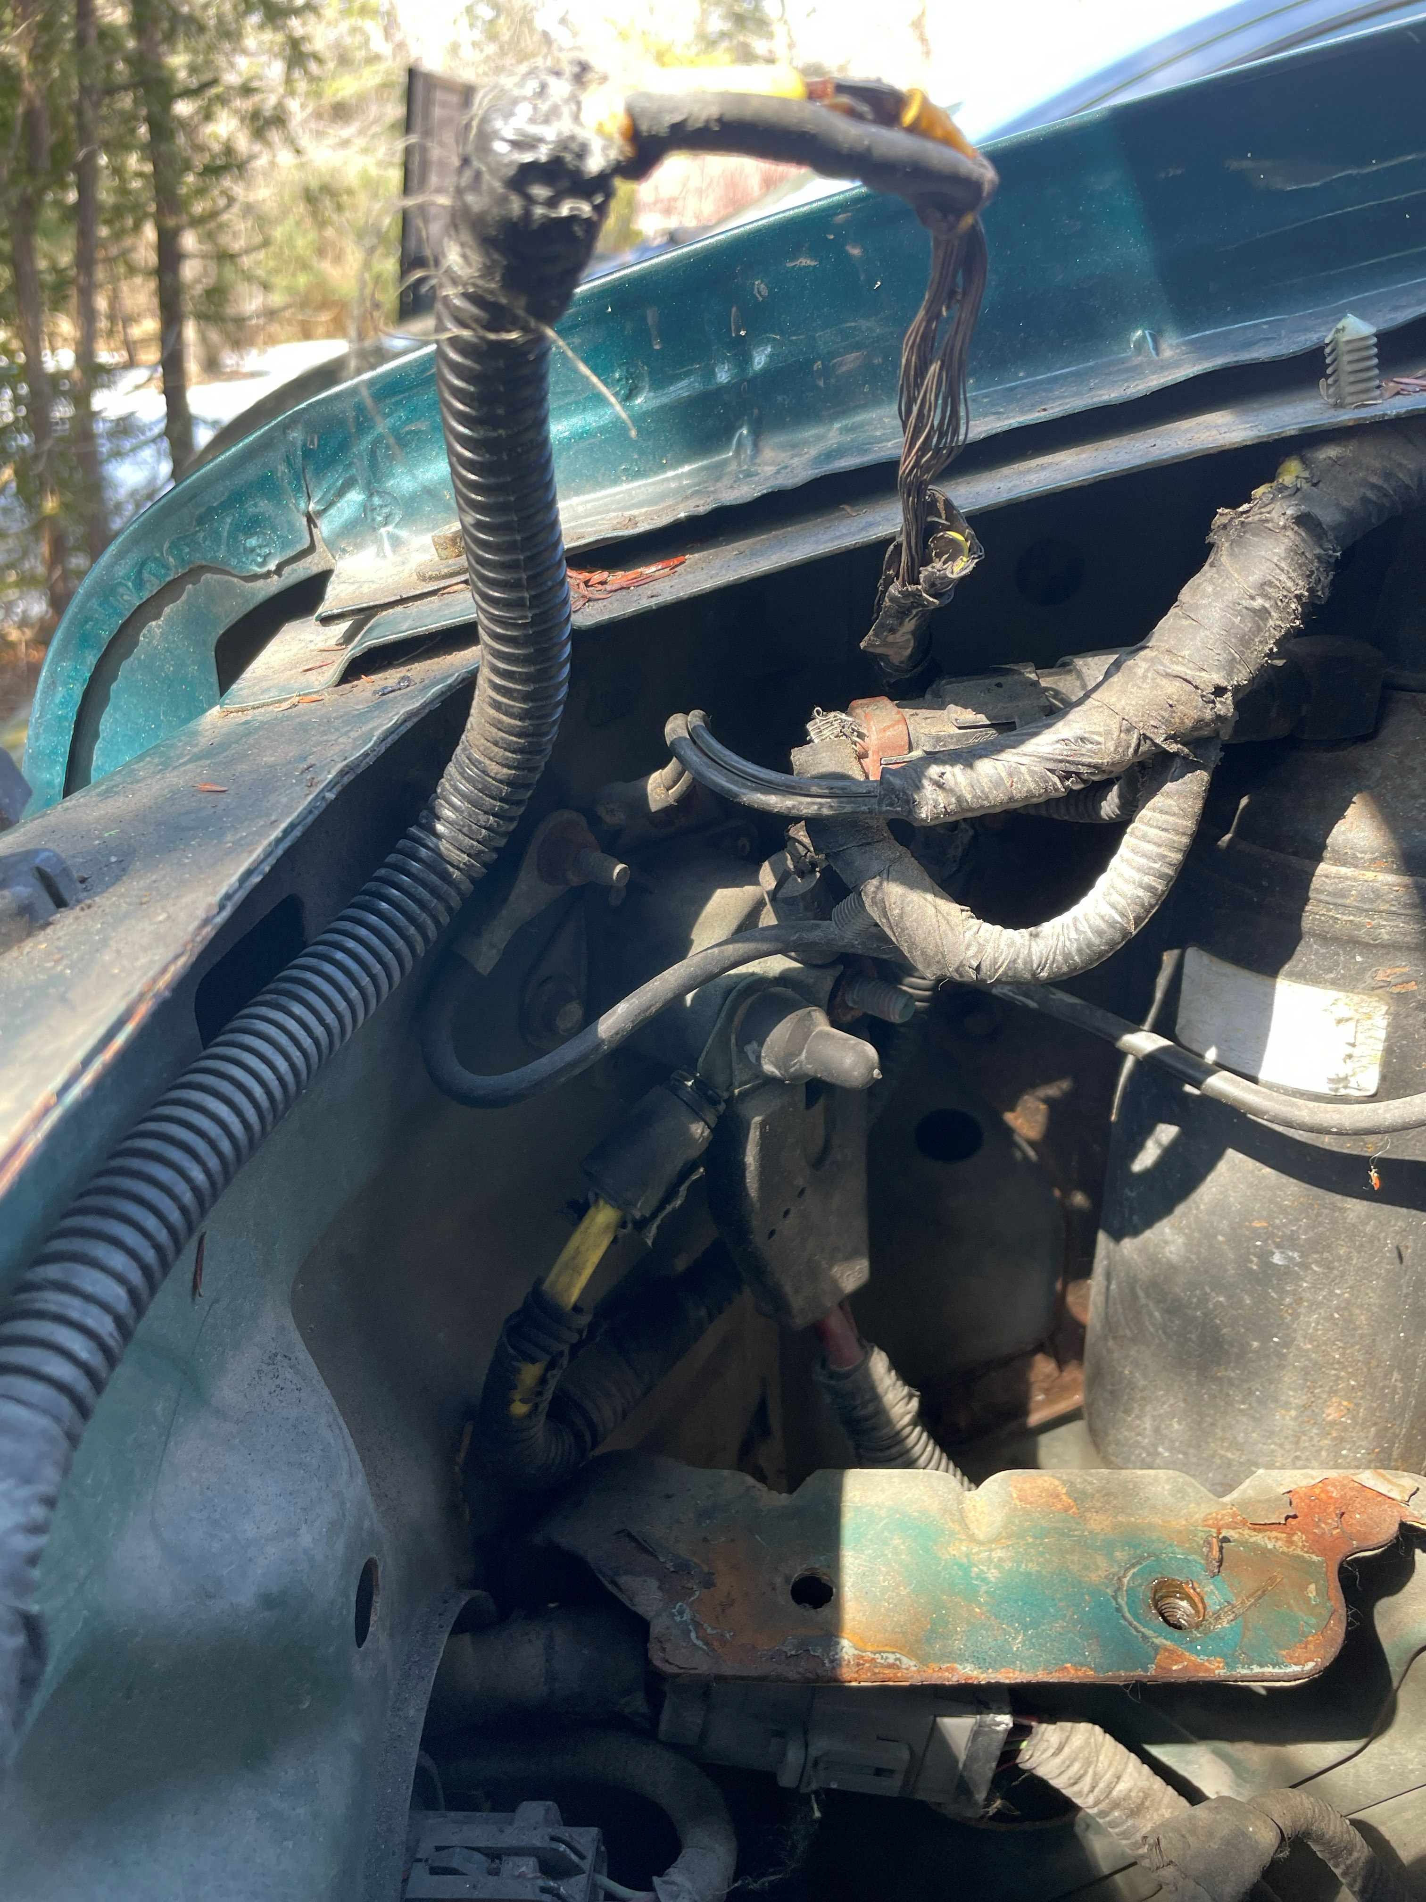
Same cable
Bends around and disappears behind items here
Connects Here

