When I connect the battery a cable starts smoking
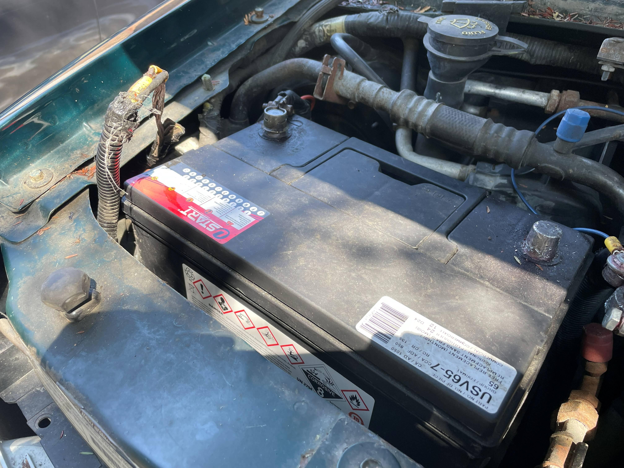
This cable

I took the battery out and traced the cable:
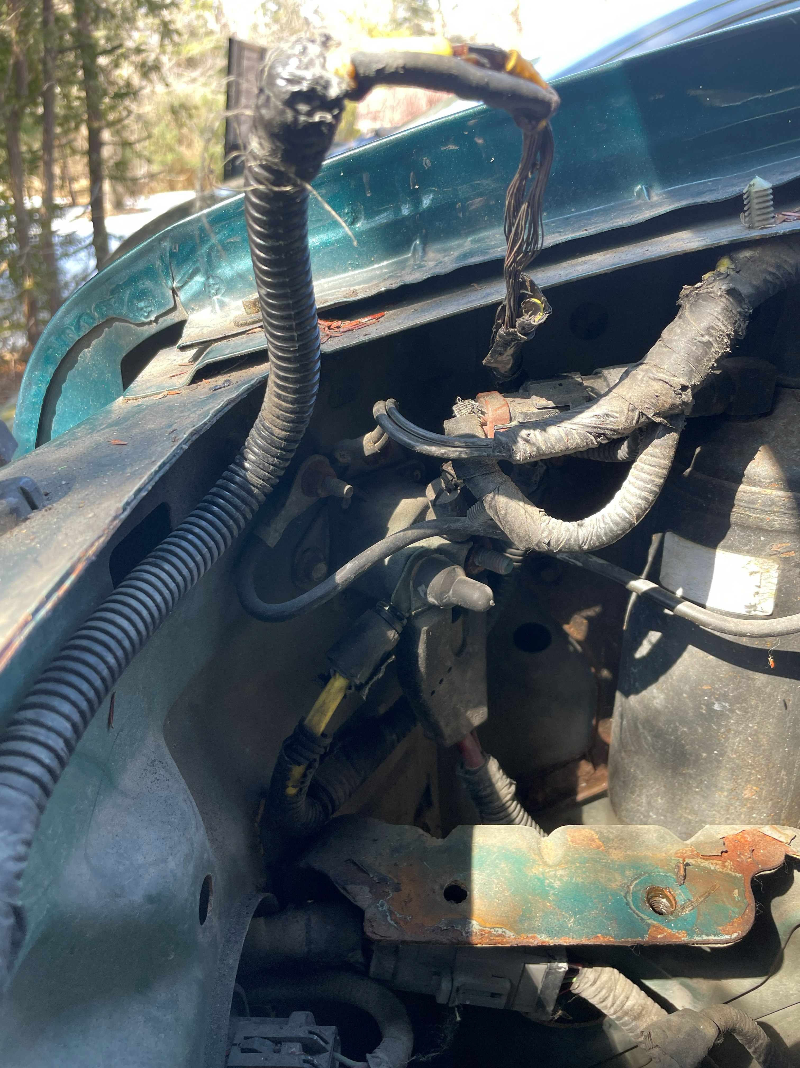
Same cable
Bends around and disappears behind items here
Connects Here
The cable is clipped to the front of the engine bay and terminates at the fuse box:
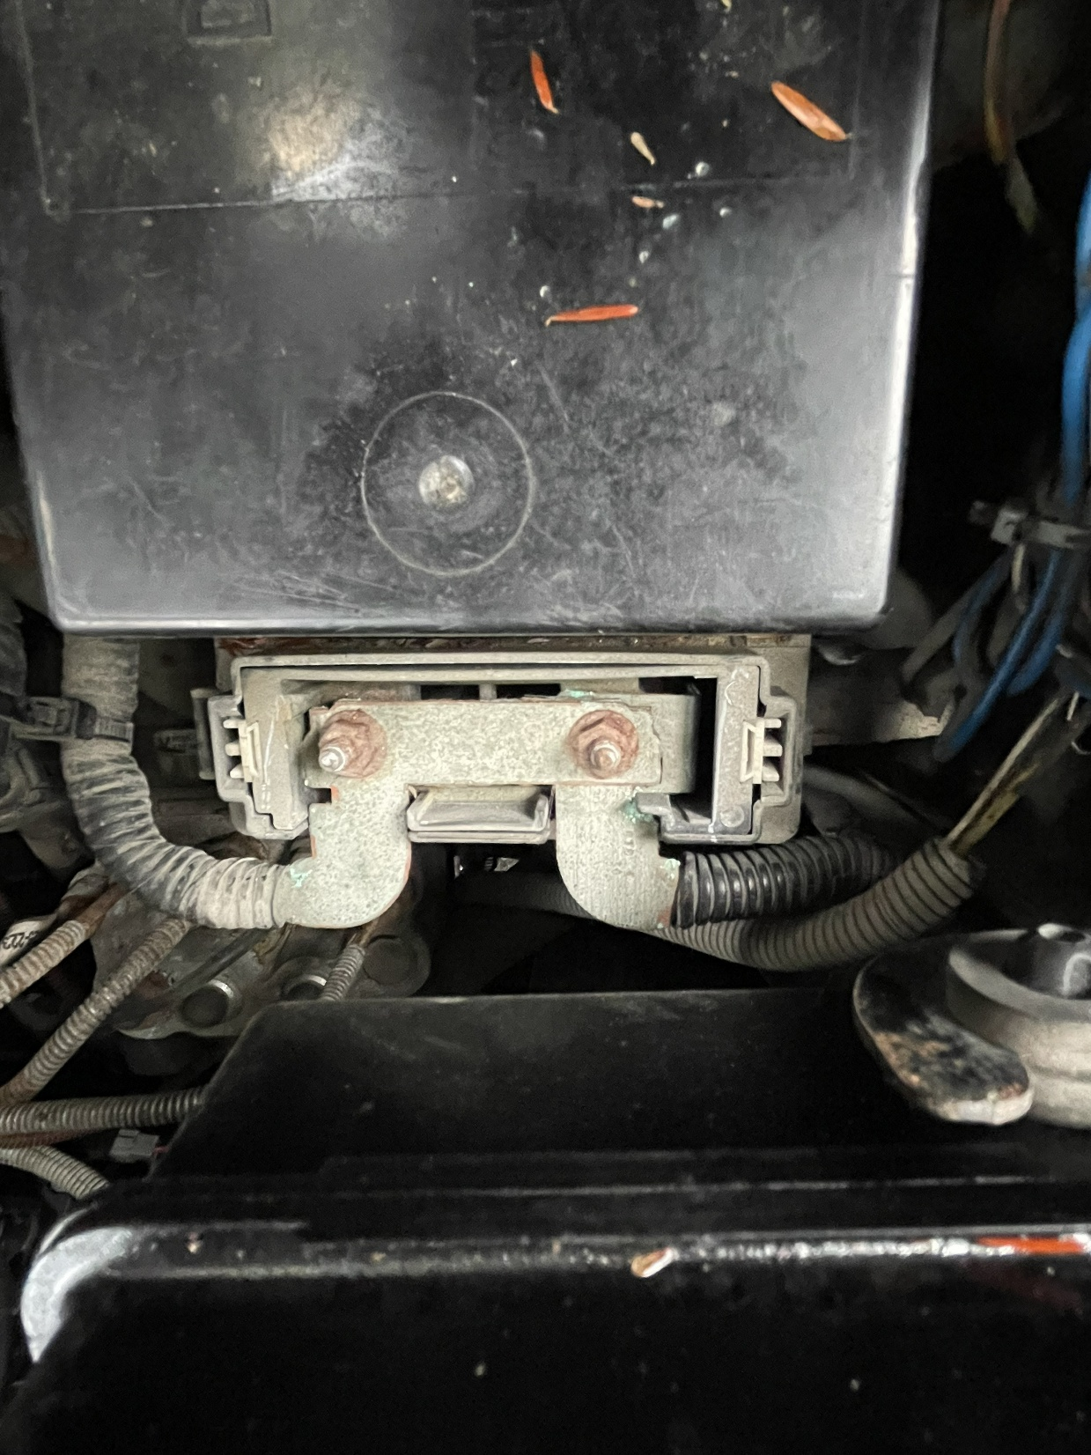
Cover says:
ALT +

Fuse box RHS engine bay.
Cable terminates here

