Generator - 1.5L EcoBoost (118kW/160PS) – I4
Removal
- Disconnect the negative battery cable.
Refer to: Battery Disconnect and Connect (414-01 Battery, Mounting and Cables, General Procedures).
- NOTE: Vehicle with Auto-Start-Stop System shown, other vehicles similar.
Remove the stud bolt and the generator bracket.
Torque: 35 lb.ft (47 Nm)
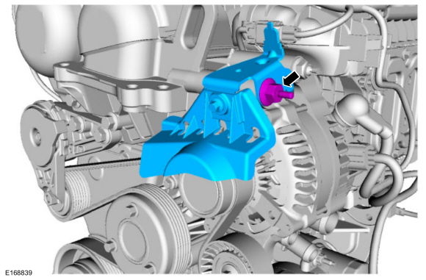
- Rotate the accessory drive belt tensioner counterclockwise and position aside the accessory drive belt.
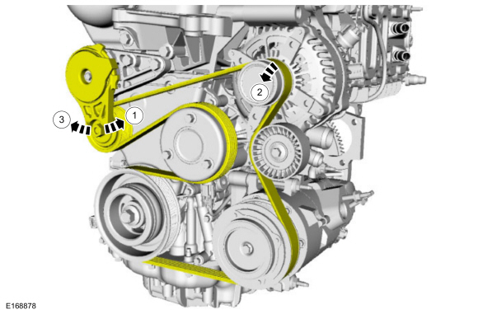
- Detach the retainers and position aside the wire harness.
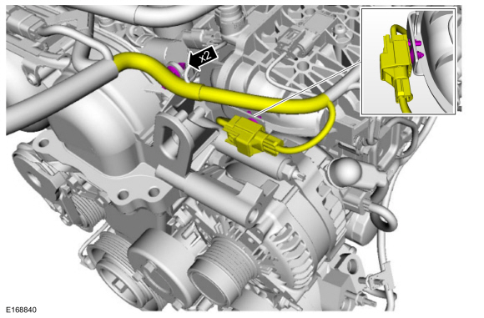
- NOTICE: When installing the B+ terminal nut to the generator, hand start the nut before tightening or component damage may occur.
  - Disconnect the generator electrical connector.
  - Position the protective cover aside. Remove the nut and position aside the generator B+ cable.
Torque: 150 lb.in (17 Nm)
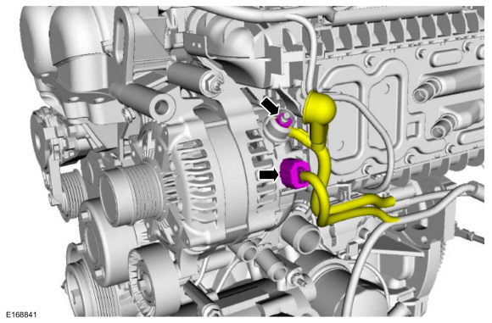
- Remove the generator mounting nut.
Torque: 35 lb.ft (47 Nm)
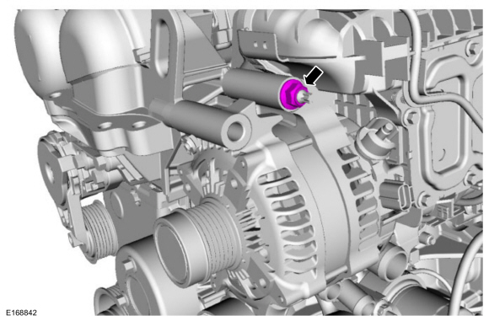
- Remove the generator stud.
Torque: 89 lb.in (10 Nm)
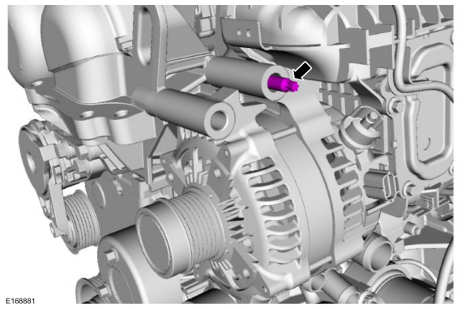
- Remove the lower generator bolt and remove the generator.
Torque: 35 lb.ft (47 Nm)
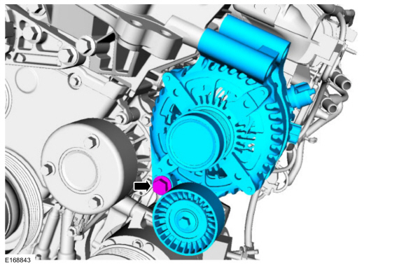
- NOTE: This step is only necessary when installing a new component.
Remove the bolt and the idler pulley.
Torque: 18 lb.ft (25 Nm)
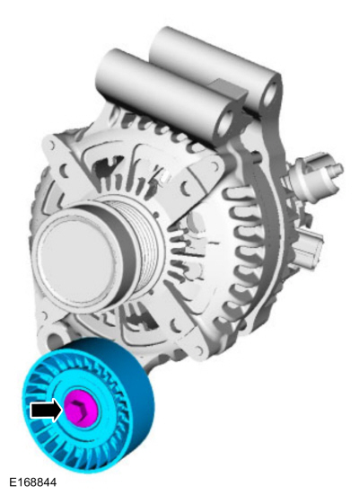
Installation
- To install, reverse the removal procedure.

