Coolant Pump
Special Tool(s) / General Equipment
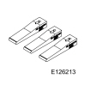 | 303-1556  Locking Tool, Timing Belt  TKIT-2010B-FLM  TKIT-2010B-ROW
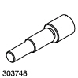 | 303-748  Locking Tool, Crankshaft  TKIT-2010B-FLM  TKIT-2010B-ROW
Hose Clamp Remover/Installer
4 mm Drill Bit
Removal
NOTE: The original coolant pump may not be equipped with a clutch and wiring harness connector.
- Refer to: Engine Cooling System Health and Safety Precautions (100-00 General Information, Description and Operation).
- Drain the cooling system.
Refer to: Engine Cooling System Draining, Vacuum Filling and Bleeding (303-03A Engine Cooling - 1.5L EcoBoost (118kW/160PS) – I4, General Procedures).
- Remove the engine appearance cover.
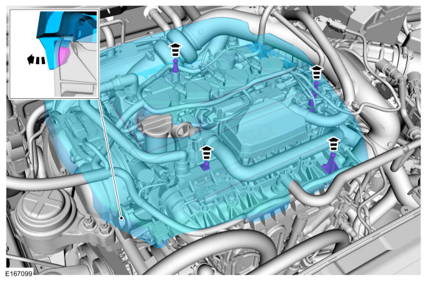
- Disconnect the electrical connector.
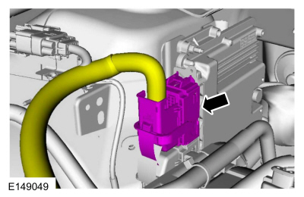
- Detach the wiring harness hose assembly and disconnect the electrical connector.
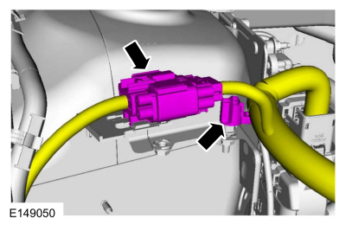
- Remove the following items:
  - Remove the air cleaner outlet pipe.
Refer to: Air Cleaner Outlet Pipe (303-12A Intake Air Distribution and Filtering - 1.5L EcoBoost (118kW/160PS) – I4, Removal and Installation).
- Remove the crankcase vent hose.
Use the General Equipment: Hose Clamp Remover/Installer
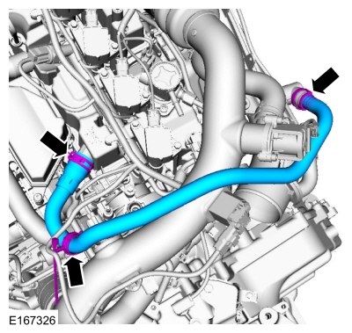
- Release the clamp and disconnect the bypass hose. Detach the wiring harness pin-type retainers and loosen the clamp.
Use the General Equipment: Hose Clamp Remover/Installer
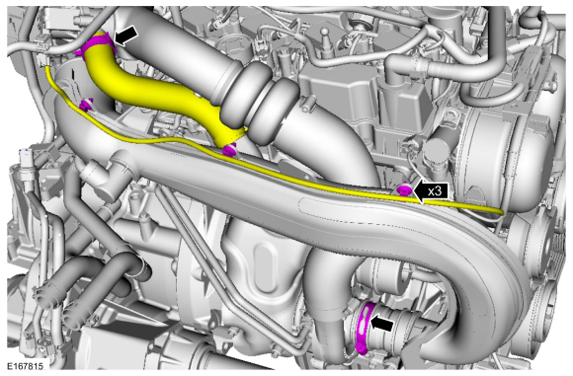
- Remove the bolts and the TC inlet pipe.
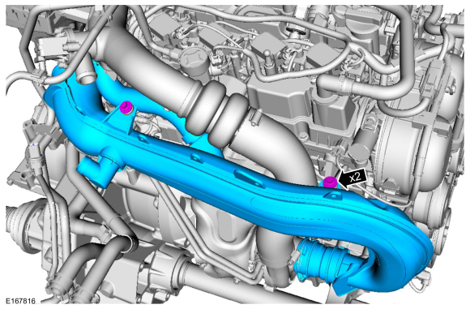
- Loosen the coolant pump pulley bolts.
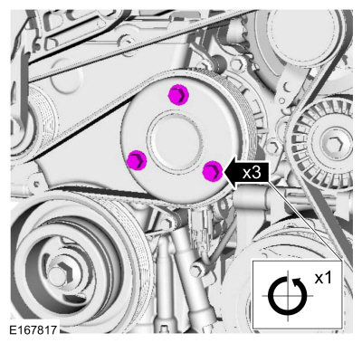
- Refer to: Jacking and Lifting - Overview (100-02 Jacking and Lifting, Description and Operation).
- Remove the nuts and the axle bearing support.
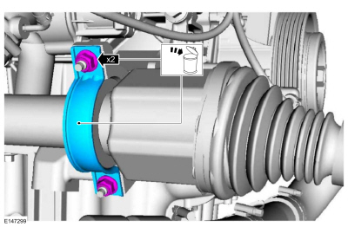
- NOTE: It may be necessary to rotate the halfshaft to remove the front lower bolt.
Remove the bolts and position the bracket support aside.
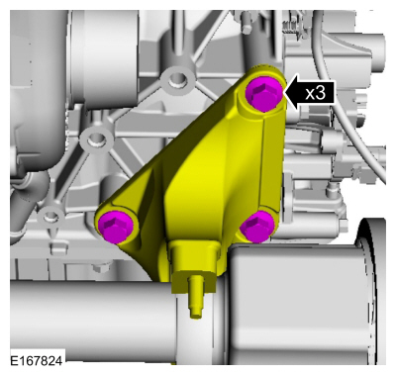
- Remove the engine block bolt.
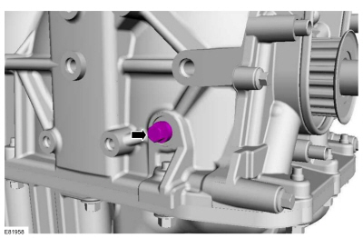
- Install Special Service Tool: 303-748 Locking Tool, Crankshaft.
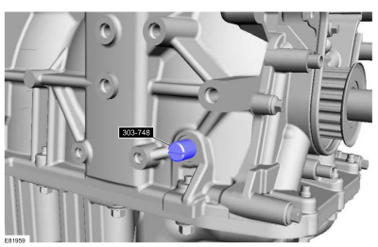
- NOTICE: Only rotate the crankshaft clockwise.
Rotate the crankshaft slowly until the crankshaft stops.
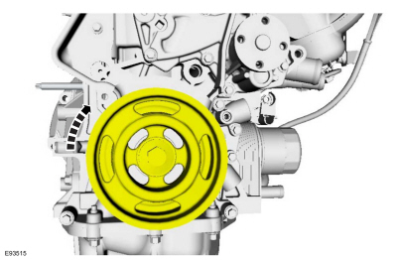
- Remove the following items:
  - Remove the generator.
Refer to: Generator - 1.5L EcoBoost (118kW/160PS) – I4 (414-02 Generator and Regulator, Removal and Installation).
  - Remove the engine mount.
Refer to: Engine Mount (303-01A Engine - 1.5L EcoBoost (118kW/160PS) – I4, Removal and Installation).
- Remove the bolts and the accessory drive belt tensioner.
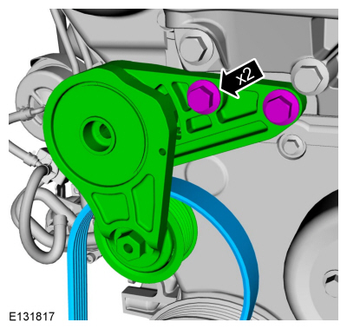

  - Detach the wiring harness retainer and remove the nut.
  - Remove the bolt and the supporting bracket.
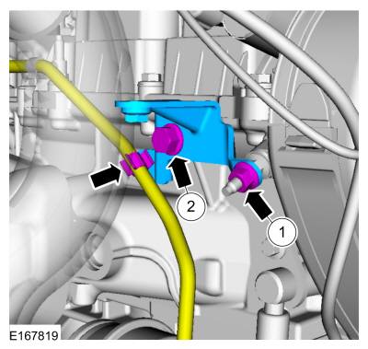

  - Remove the timing cover stud bolt.
  - Detach the cover from the retainer and open.
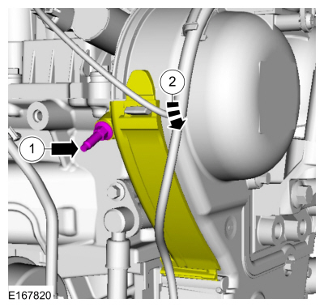

  - Remove the bolts and the coolant pump pulley.
  - Remove the engine mount stud.
  - Detach the wiring harness retainers.
  - Remove the bolt.
  - Detach the wiring harness retainer.
  - Remove the bolt.
  - Remove the bolts.
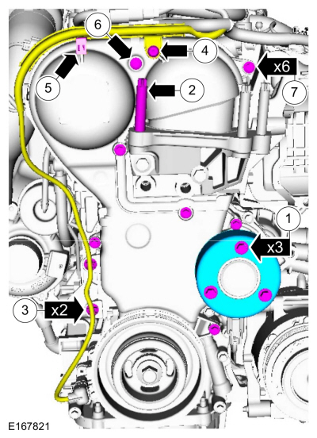
- NOTE: If the vehicle is equipped with a coolant pump that has a clutch, it may be necessary to break the timing belt cover during removal. Install a new timing belt cover.
Remove the timing belt cover.
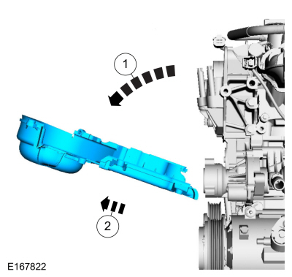
- NOTE: Timing belt removal is only necessary if a new timing belt is being installed.
Install a new timing belt if the existing belt is contaminated by coolant or oil.
Refer to: Timing Belt (303-01A Engine - 1.5L EcoBoost (118kW/160PS) – I4, Removal and Installation).
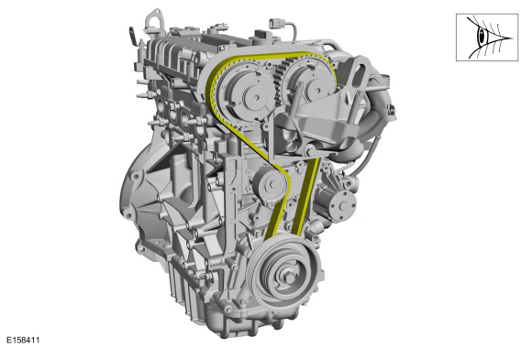
- NOTE: The original coolant pump may not be equipped with a clutch and wiring harness connector.
Disconnect the electrical connector.
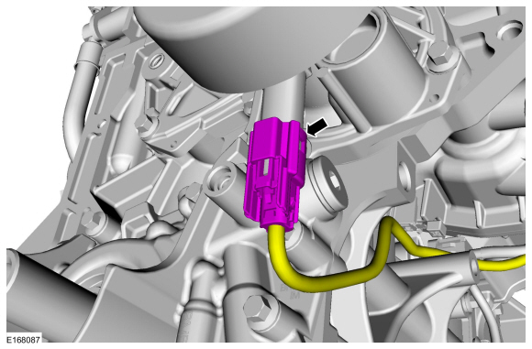

  - NOTICE: Only use the specified special tool.
NOTICE: Make sure that the crankshaft is not rotated while the special tool is installed.
Install Special Service Tool: 303-1556 Locking Tool, Timing Belt.
  - NOTICE: Note the position of the components before removal.
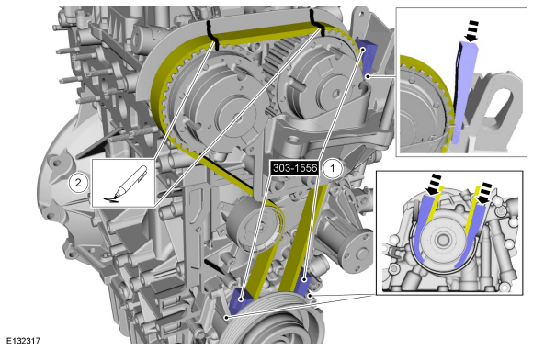
- WARNING: The tensioner is under spring tension. Be careful when handling the tensioner. Failure to follow this instruction may result in personal injury.
NOTICE: The crankshaft or camshafts must not be rotated while the timing belt is removed.
Rotate the timing belt tensioner and install a holding pin.
Install the General Equipment: 4 mm Drill Bit
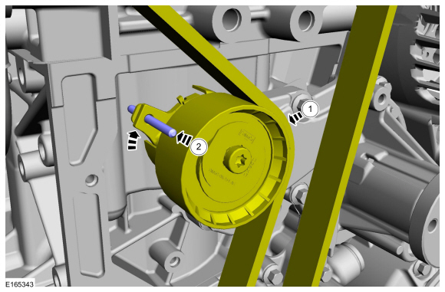
- WARNING: The tensioner is under spring tension. Be careful when handling the tensioner. Failure to follow this instruction may result in personal injury.
Remove the bolt and timing belt tensioner.
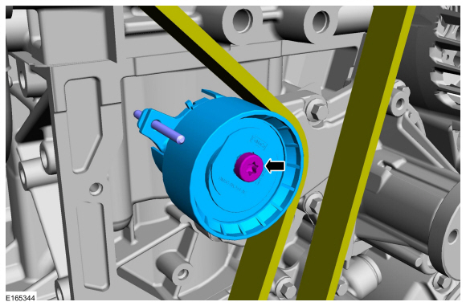

  - Protect the timing belt and the lower timing belt cover from contamination by the coolant.
  - Remove the bolts and the coolant pump.
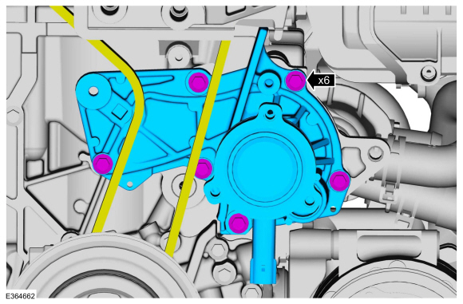
- Remove and discard the gasket.
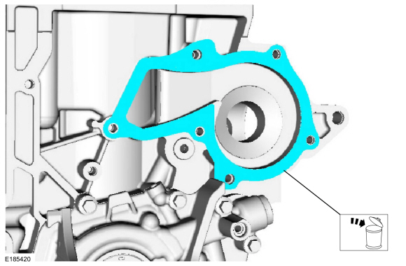
Installation
NOTE: The replacement coolant pump is not equipped with a clutch and engine harness connector plug. Check OASIS for any applicable SSMs. If an SSM exists, follow SSM instructions. When the original coolant pump is equipped with a clutch and engine harness connector, cut the harness connector off, use heat shrink to seal the wire ends, and tape back the wires as needed.
- NOTE: Make sure that the mating faces are clean and free of foreign material.
Install a new gasket.
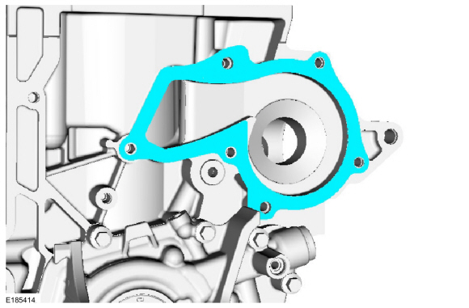
- Install the coolant pump and the bolts.
Torque:
Stage 1: 53 lb.in (6 Nm)
Stage 2: 89 lb.in (10 Nm)
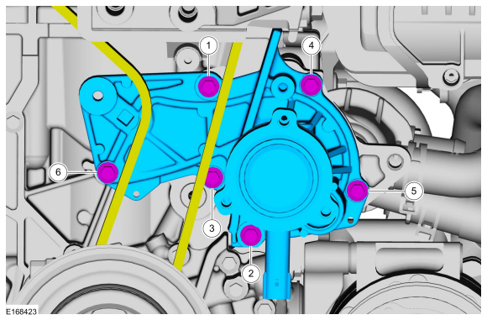
- NOTE: Make sure that the components are installed to the position noted before removal.
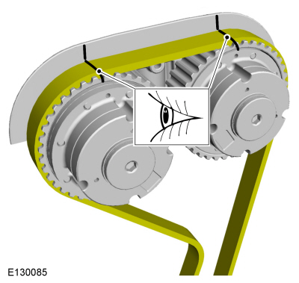
- WARNING: The tensioner is under spring tension. Be careful when handling the tensioner. Failure to follow this instruction may result in personal injury.
  - Install the timing belt tensioner and tighten the bolt.
Torque: 18 lb.ft (25 Nm)
  - Remove the holding pin.
Remove the General Equipment: 4 mm Drill Bit
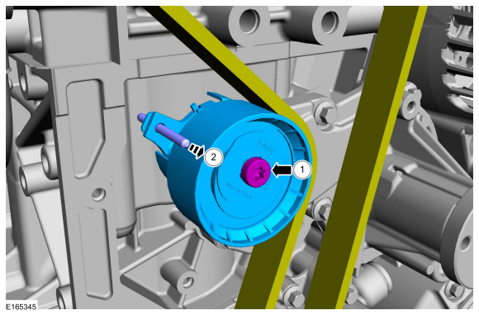

  - NOTE: Make sure that the components are installed to the position noted before removal.
  - Remove Special Service Tool: 303-1556 Locking Tool, Timing Belt.
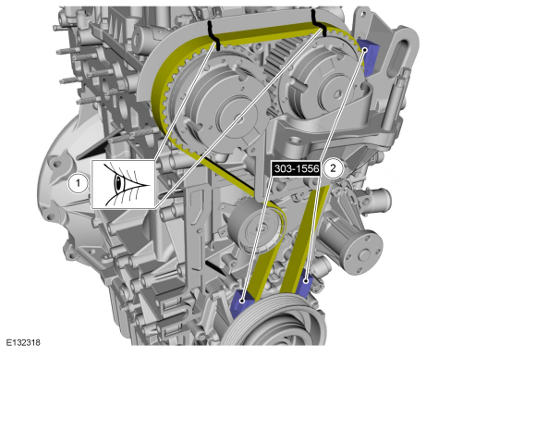
- Remove Special Service Tool: 303-748 Locking Tool, Crankshaft.
- Install and tighten the engine block bolt.
Torque: 177 lb.in (20 Nm)
- Rinse residual engine coolant off the timing belt and the related drive components.
- Install the timing belt cover.
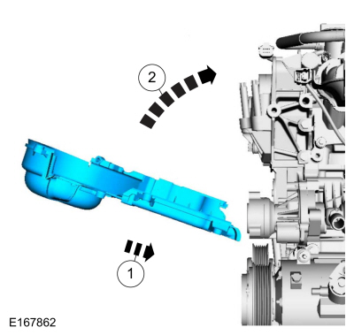

  - Install the timing belt cover bolts.
Torque: 89 lb.in (10 Nm)
  - Install the bolt.
Torque: 89 lb.in (10 Nm)
  - Install and tighten the engine mount stud.
Torque: 71 lb.in (8 Nm)
  - NOTE: Only tighten the bolts finger tight at this stage.
Install the coolant pump pulley and tighten the bolts.
  - Position the wiring aside assembly and attach the wiring harness retainer.
  - Install and tighten the bolt.
  - Attach the wiring harness retainers.
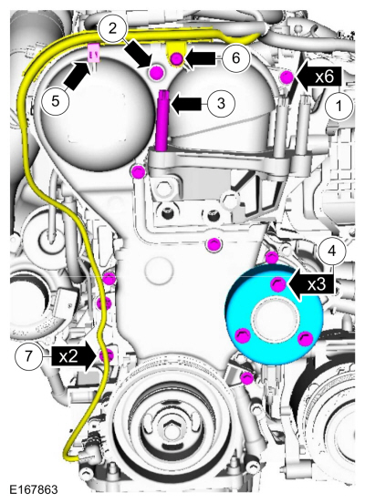

  - Close the cover and attach the retainer.
  - Install and tighten the timing cover stud bolt.
Torque: 89 lb.in (10 Nm)
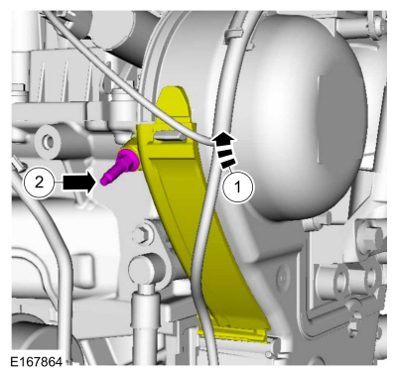

  - Install the supporting bracket and tighten the nut.
Torque: 62 lb.in (7 Nm)
  - Install the bolt and attach the wiring harness retainer.
Torque: 17 lb.ft (23 Nm)
- Install the accessory drive tensioner and tighten the bolts.
Torque: 35 lb.ft (48 Nm)
- Install the following items:
  - Install the engine mount.
Refer to: Engine Mount (303-01A Engine - 1.5L EcoBoost (118kW/160PS) – I4, Removal and Installation).
  - Install the generator.
Refer to: Generator - 1.5L EcoBoost (118kW/160PS) – I4 (414-02 Generator and Regulator, Removal and Installation).
- Position the support bracket and tighten the bolts.
Torque: 35 lb.ft (48 Nm)
- NOTE: Make sure that a new component is installed.
Install the axle bearing support and tighten the nuts.
Torque:
Stage 1: 44 lb.in (5 Nm)
Stage 2: 18 lb.ft (25 Nm)
Stage 3: 18 lb.ft (25 Nm)
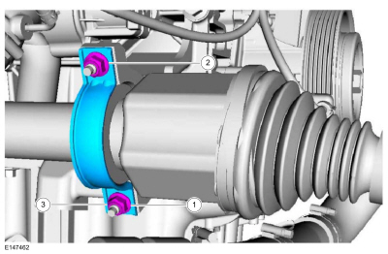
- Install the underbody shield and the retainers.
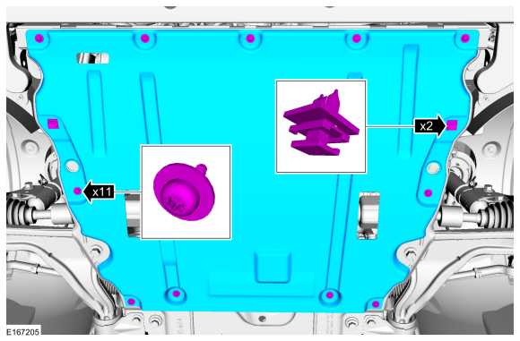
- Tighten the bolts.
Torque: 18 lb.ft (24 Nm)
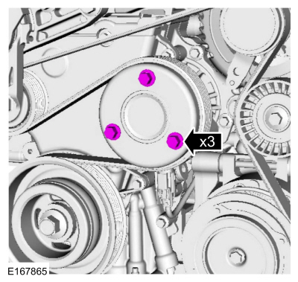
- Install the TC inlet pipe and tighten the bolts.
Torque: 71 lb.in (8 Nm)

  - Tighten the clamp.
Torque: 44 lb.in (5 Nm)
  - Connect the bypass hose and attach the wiring harness retainers.
Use the General Equipment: Hose Clamp Remover/Installer
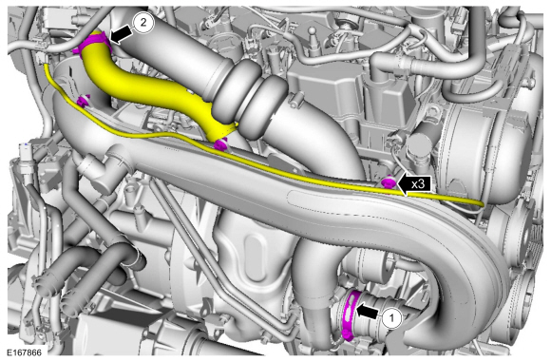
- Install the vent hose.
Use the General Equipment: Hose Clamp Remover/Installer
- Install the following items:
  - Install the air cleaner outlet pipe.
Refer to: Air Cleaner Outlet Pipe (303-12A Intake Air Distribution and Filtering - 1.5L EcoBoost (118kW/160PS) – I4, Removal and Installation).
- Connect the electrical connector and attach the wiring harness retainer.
- Connect the electrical connector.
- Install the engine appearance cover.
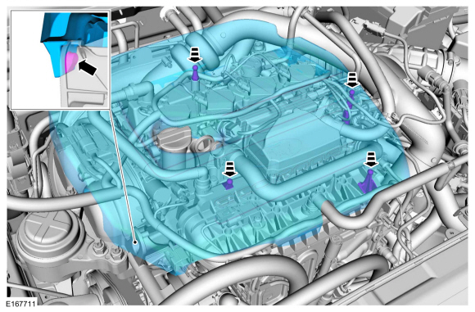
- Fill the bleed the cooling system.
Refer to: Engine Cooling System Draining, Vacuum Filling and Bleeding (303-03A Engine Cooling - 1.5L EcoBoost (118kW/160PS) – I4, General Procedures).

