Timing Belt
Special Tool(s) / General Equipment
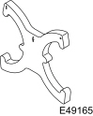 | 303-1097  Locking Tool, Variable Camshaft Timing Oil Control Unit  TKIT-2010B-FLM  TKIT-2010B-ROW
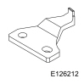 | 303-1550  Alignment Tool, Crankshaft Vibration Damper  TKIT-2012A-FL  TKIT-2012A-ROW
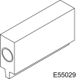 | 303-393-02  Adapter for 303-393  TKIT-2012A-FL  TKIT-2012A-ROW
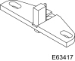 | 303-393A  Locking Tool, Flywheel  TKIT-2012A-FL  TKIT-2012A-ROW
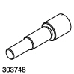 | 303-748  Locking Tool, Crankshaft  TKIT-2010B-FLM  TKIT-2010B-ROW
Trolley Jack
Hose Clamp Remover/Installer
Wooden Block
Removal
NOTICE: Do not loosen or remove the crankshaft pulley bolt without first installing the special tools. The crankshaft pulley and the crankshaft timing sprocket are not keyed to the crankshaft. Before any repair requiring loosening or removal of the crankshaft pulley bolt, the crankshaft and camshafts must be locked in place by the special service tools, otherwise severe engine damage can occur.
NOTE: During engine repair procedures, cleanliness is extremely important. Any foreign material, including any material created while cleaning gasket surfaces, that enters the oil passages, coolant passages or the oil pan can cause engine failure.
- With the vehicle in NEUTRAL, position it on a hoist.
Refer to: Jacking and Lifting - Overview (100-02 Jacking and Lifting, Description and Operation).
- Disconnect the PCM electrical connector.
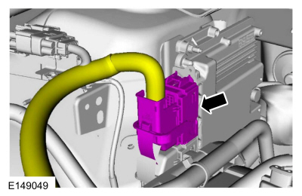
- Detach the retainer and disconnect the electrical connector.
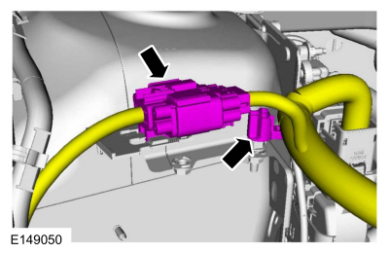
- Remove the following items:
  - Refer to: Degas Bottle (303-03A Engine Cooling - 1.5L EcoBoost (118kW/160PS) – I4, Removal and Installation).
  - Refer to: Air Cleaner Outlet Pipe (303-12A Intake Air Distribution and Filtering - 1.5L EcoBoost (118kW/160PS) – I4, Removal and Installation).
- Detach the retainer, disconnect and remove the crankcase vent hose.
Use the General Equipment: Hose Clamp Remover/Installer
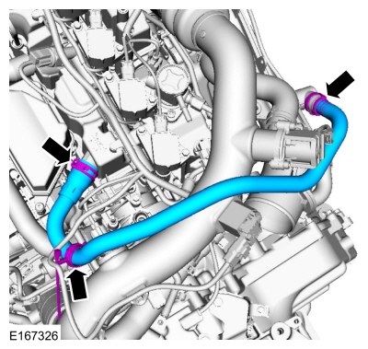

  - Detach the wiring harness retainers and disconnect the TC bypass hose.
Use the General Equipment: Hose Clamp Remover/Installer
  - Loosen the TC inlet hose clamp.
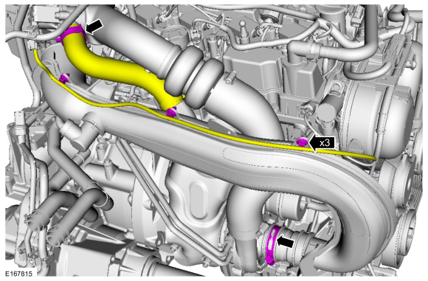
- Remove the bolts and the TC inlet pipe assembly.
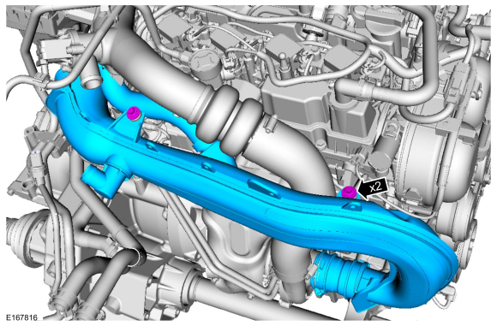
- Loosen the coolant pump pulley bolts.
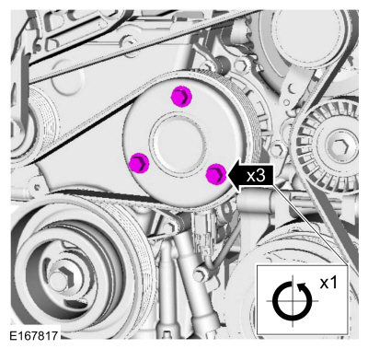
- Remove the following items:
  - Remove the RH front wheel and tire.
Refer to: Wheel and Tire (204-04A Wheels and Tires, Removal and Installation).
  - Remove the RH front fender splash shield.
Refer to: Fender Splash Shield (501-02 Front End Body Panels, Removal and Installation).
- Remove the retainers and the engine undershield.
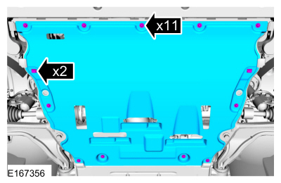
- Remove and discard the RH halfshaft bearing retaining strap and the nuts.
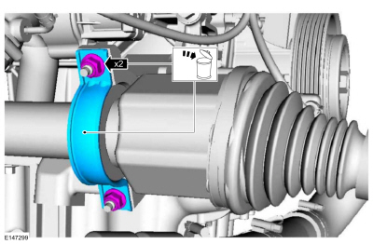
- NOTE: It may be necessary to rotate the halfshaft to remove the front lower bolt.
Remove the RH halfshaft supports bracket bolts.
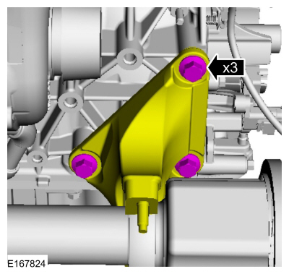
- Remove the engine plug bolt.
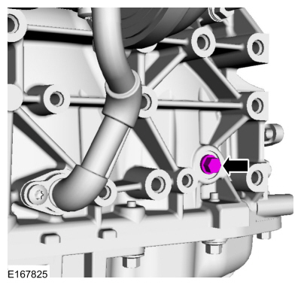
- Remove the following items:
  - Refer to: Starter Motor (303-06A Starting System - 1.5L EcoBoost (118kW/160PS) – I4, Removal and Installation).
  - Refer to: Generator - 1.5L EcoBoost (118kW/160PS) – I4 (414-02 Generator and Regulator, Removal and Installation).
- Install the following items:
  - Use the General Equipment: Trolley Jack
Use the General Equipment: Wooden Block
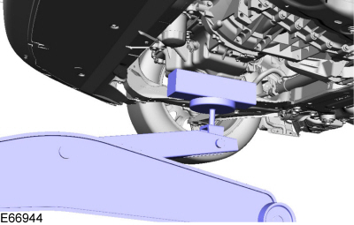
- Remove the nuts, bolts and the engine mount.
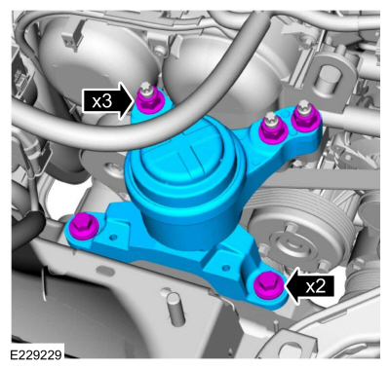
- Remove the bolts, accessory drive belt tensioner and the accessory drive belt.
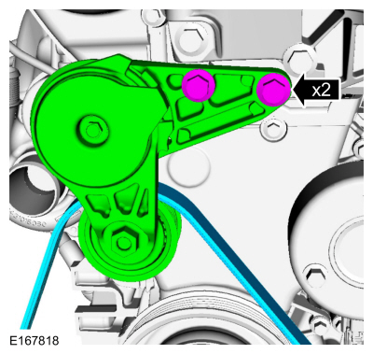

  - Detach the vacuum tube retainer.
  - Remove the bolt, nut and the support bracket.
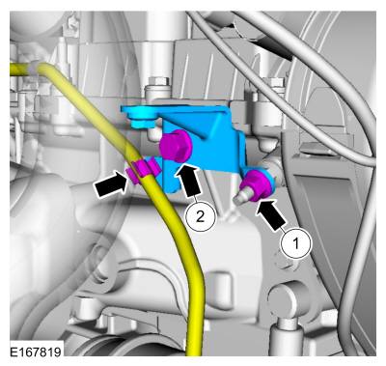
- Remove the stud bolt and the cover from front cover.
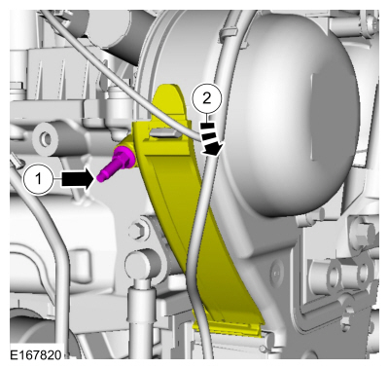

  - Remove the bolts and the coolant pump pulley.
  - Remove the engine mount stud and detach the wiring harness retainers.
  - Remove the engine front cover bolts.
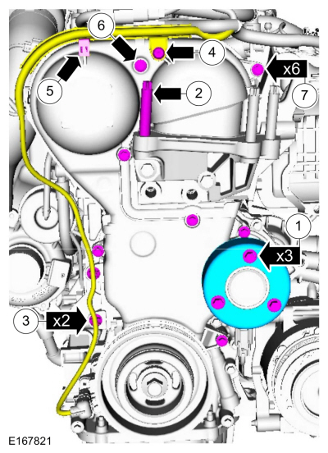
- NOTE: If the vehicle is equipped with a coolant pump that has a clutch, it may be necessary to break the timing belt cover during removal. If the timing belt is being installed on a vehicle with a coolant pump that has a clutch, install a new coolant pump and timing belt cover. Refer to coolant pump.
Remove the engine front cover.
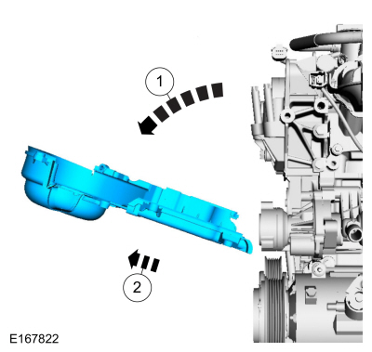
- NOTE: Note the different lengths of the bolts for installation.
Detach the wiring harness retainers, remove the bolts and the engine mount support bracket.
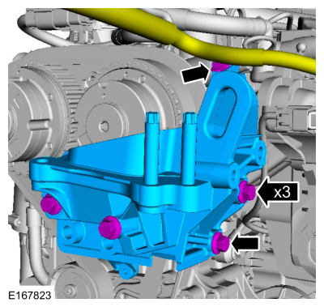
- NOTE: Only rotate the crankshaft in a clockwise direction.
Rotate the crankshaft in a clockwise direction and position the VCT marking at 11 o'clock position.
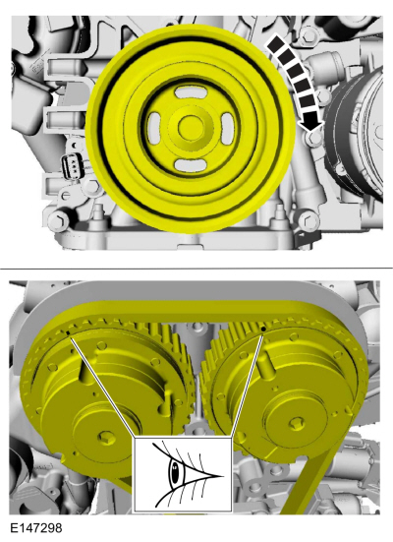
- NOTE: The Crankshaft TDC Timing Pin will contact the crankshaft and prevent it from turning past TDC. However, the crankshaft can still be rotated in the counterclockwise direction. The crankshaft must remain at the TDC position during the crankshaft pulley removal and installation.
Install Special Service Tool: 303-748 Locking Tool, Crankshaft.
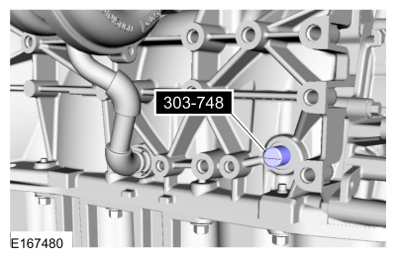
- NOTE: Only rotate the crankshaft clockwise direction.
Rotate the crankshaft slowly clockwise until the crankshaft balance weight is up against the crankshaft locking tool. The engine is now at TDC.
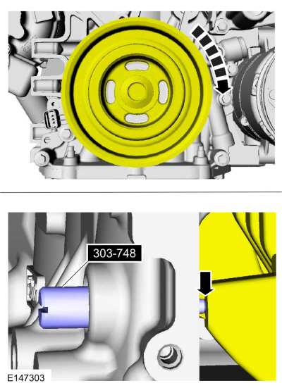
- Install Special Service Tool: 303-393-02 Adapter for 303-393. , 303-393A Locking Tool, Flywheel.
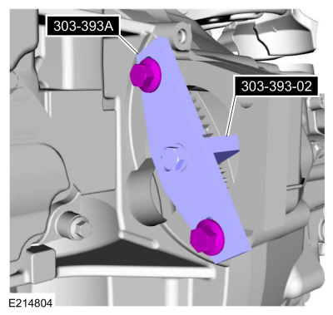
- Remove and discard the crankshaft pulley bolt. Remove the crankshaft pulley.
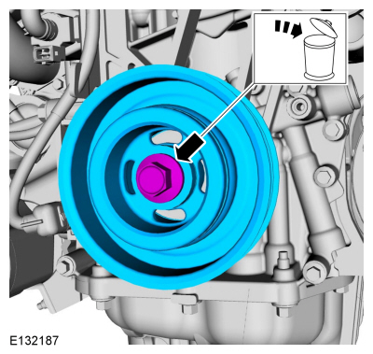
- NOTE: The timing mark of each VCT unit must be at the 12 o'clock position.
NOTE: It may necessary to rotate the camshafts slightly to install the special tool.
Install Special Service Tool: 303-1097 Locking Tool, Variable Camshaft Timing Oil Control Unit.
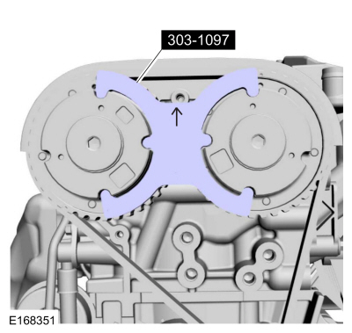
- WARNING: The timing belt tensioner spring is under load. Extra care must be taken at all times when handling the tensioner. Failure to follow this instruction may result in personal injury.
NOTE: Install a holding pin.
  - Rotate the timing belt tensioner clockwise.
  - Install a holding pin.
  - Remove the timing belt.
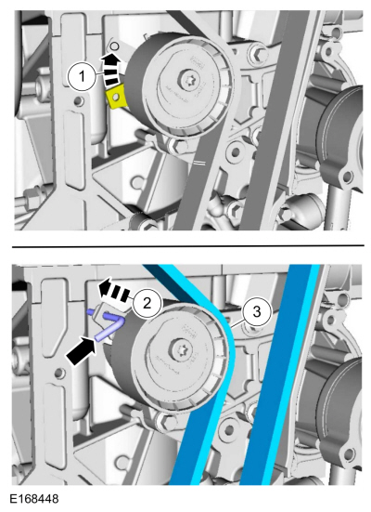
- Remove the crankshaft sprocket.
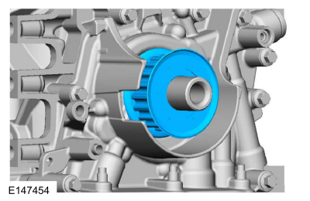

  - Disconnect the CKP sensor electrical connector.
  - Remove the bolt and the CKP sensor.
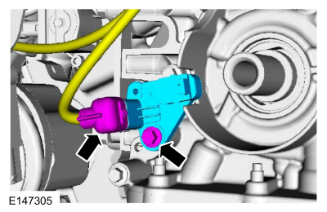
Installation
- NOTE: Before installation, clean and inspect the sprocket for any damage. If damage is evident, replace the sprocket. If no damage, the sprocket is to be reused.
Install the crankshaft sprocket.
- Install the timing belt in the following sequence.
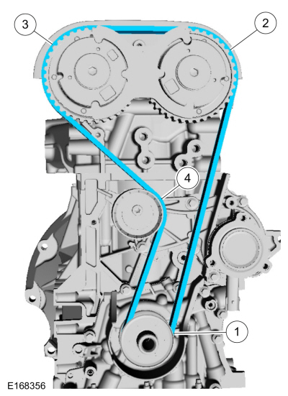
- WARNING: The timing belt tensioner spring is under load. Extra care must be taken at all times when handling the tensioner. Failure to follow this instruction may result in personal injury.
Remove the holding pin.
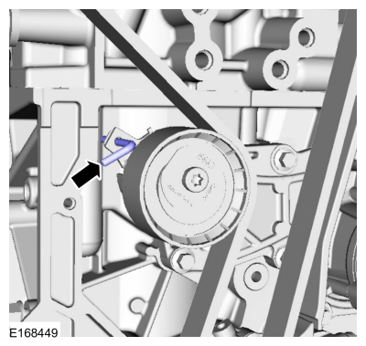
- Install the crankshaft pulley.
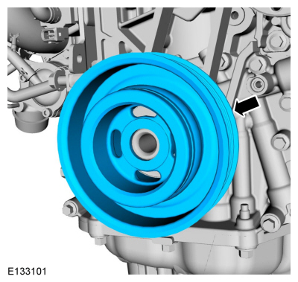

  - Install Special Service Tool: 303-1550 Alignment Tool, Crankshaft Vibration Damper.
  - Rotate crankshaft pulley to align the Special Tool:
Use Special Service Tool: 303-1550 Alignment Tool, Crankshaft Vibration Damper.
  - Finger tight at this stage.
  - Using a new bolt, finger tight at this stage.
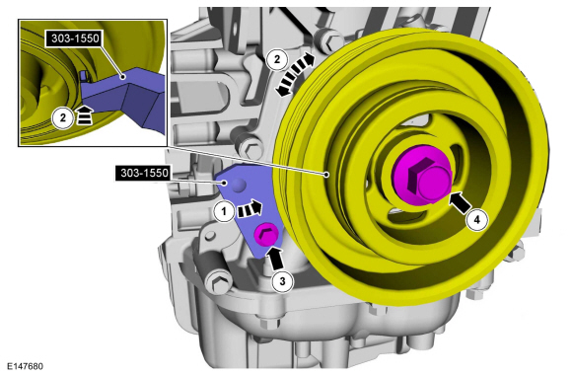
- Tighten the crankshaft pulley bolt in 4 stages.
Torque:
Stage 1: 74 lb.ft (100 Nm)
Stage 2: 90°
Stage 3: Wait 2s
Stage 4: 15°
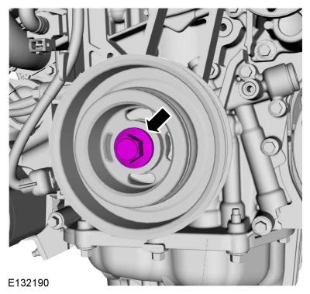
- Remove Special Service Tool: 303-1550 Alignment Tool, Crankshaft Vibration Damper.
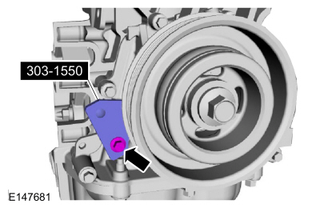
- Remove Special Service Tool: 303-748 Locking Tool, Crankshaft.
- Remove Special Service Tool: 303-393-02 Adapter for 303-393. , 303-393A Locking Tool, Flywheel.
- Remove Special Service Tool: 303-1097 Locking Tool, Variable Camshaft Timing Oil Control Unit.
- NOTE: Only rotate the crankshaft in a clockwise direction.
Rotate about 1 3/4 turns.
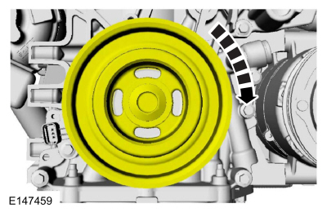
- Install Special Service Tool: 303-748 Locking Tool, Crankshaft.
- NOTE: Only rotate the crankshaft in a clockwise direction.
Rotate the crankshaft slowly clockwise until the crankshaft balance weight is up against the crankshaft locking tool. The engine is now at TDC.
- NOTE: The timing mark of each VCT unit must be at the 12 o'clock position.
NOTE: It may necessary to rotate the camshafts slightly to install the special tool.
If the special tool cannot be installed, repeat the adjustment according to the preceding steps.
Install Special Service Tool: 303-1097 Locking Tool, Variable Camshaft Timing Oil Control Unit.
- Remove Special Service Tool: 303-1097 Locking Tool, Variable Camshaft Timing Oil Control Unit.
- Install the engine mount support bracket, bolts and attach the wiring harness retainers.
Torque: 41 lb.ft (55 Nm)
- Install the engine front cover.
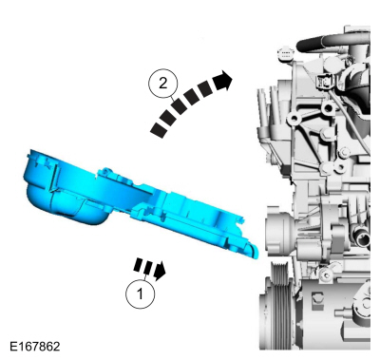

  - Install the engine front cover bolts.
Torque:
1: 89 lb.in (10 Nm)
2: 89 lb.in (10 Nm)
  - Install the engine mount stud finger-tight.
  - Install the coolant pump pulley and the bolts finger-tight.
  - Position the wiring harness, install the retainer and attach the retainers.
Torque:
5: 89 lb.in (10 Nm)
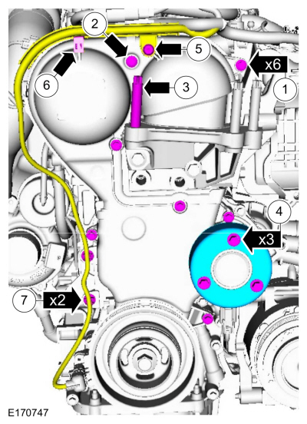
- Position the cover to engine front cover and install the stud bolt.
Torque: 89 lb.in (10 Nm)
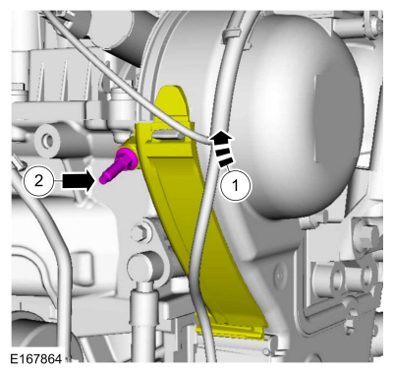

  - Install the support bracket, nut and the bolt.
Torque:
1: 17 lb.ft (23 Nm)
2: 62 lb.in (7 Nm)
  - Attach the vacuum tube retainer.
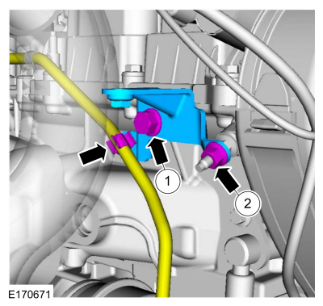
- Install the accessory drive belt, accessory drive belt idler pulley and the bolts.
Torque: 35 lb.ft (48 Nm)
- Tighten the engine mount studs.
Torque: 89 lb.in (10 Nm)
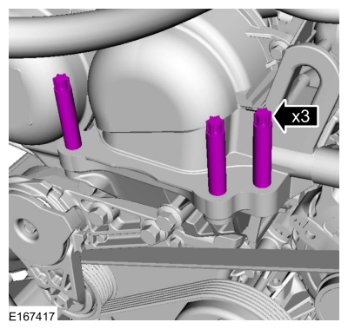
- Install the engine mount, nuts and the bolts.
Torque:
1: 85 lb.ft (115 Nm)
2: 66 lb.ft (90 Nm)
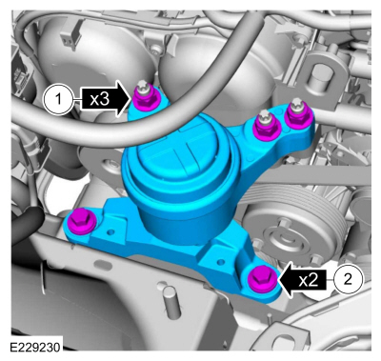
- Remove the following items:
  - Use the General Equipment: Trolley Jack
Use the General Equipment: Wooden Block
- Install the following items:
  - Refer to: Generator - 1.5L EcoBoost (118kW/160PS) – I4 (414-02 Generator and Regulator, Removal and Installation).
  - Refer to: Starter Motor (303-06A Starting System - 1.5L EcoBoost (118kW/160PS) – I4, Removal and Installation).
- Remove Special Service Tool: 303-748 Locking Tool, Crankshaft.
- Install the engine plug bolt.
Torque: 177 lb.in (20 Nm)

  - Install the CKP sensor and the bolt.
Torque: 89 lb.in (10 Nm)
  - Connect the CKP sensor electrical connector.
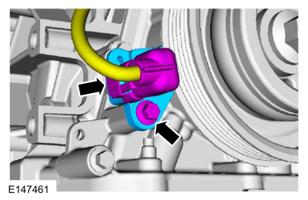
- Position the RH halfshaft support bracket and install the bolts.
Torque: 35 lb.ft (48 Nm)

  - Install the RH halfshaft retaining strap and the nuts.
Torque: 44 lb.in (5 Nm)
  - Tighten the RH halfshaft retaining strap nut.
Torque: 18 lb.ft (25 Nm)
  - Tighten the RH halfshaft retaining strap nut.
Torque: 18 lb.ft (25 Nm)
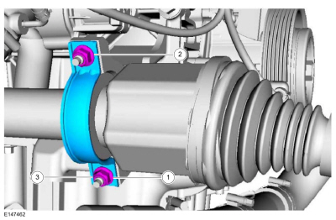
- Install the engine undershield and the retainers.
- Install the following items:
  - Install the RH front fender splash shield.
Refer to: Fender Splash Shield (501-02 Front End Body Panels, Removal and Installation).
  - Install the RH front wheel and tire.
Refer to: Wheel and Tire (204-04A Wheels and Tires, Removal and Installation).
- Tighten coolant pump pulley bolts.
Torque: 18 lb.ft (24 Nm)
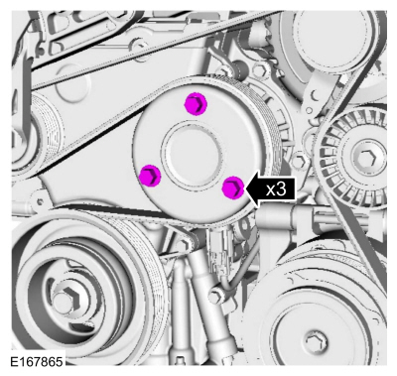
- Install the TC inlet pipe assembly and the bolts.
Torque: 71 lb.in (8 Nm)

  - Tighten the TC inlet pipe clamp.
Torque: 44 lb.in (5 Nm)
  - Connect the TC bypass hose and attach the wiring harness retainers.
Use the General Equipment: Hose Clamp Remover/Installer
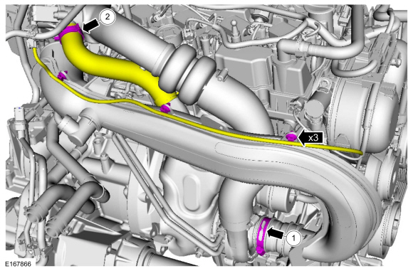
- Install and connect the crankcase vent hose and attach the retainer.
Use the General Equipment: Hose Clamp Remover/Installer
- Install the following items:
  - Refer to: Air Cleaner Outlet Pipe (303-12A Intake Air Distribution and Filtering - 1.5L EcoBoost (118kW/160PS) – I4, Removal and Installation).
  - Refer to: Degas Bottle (303-03A Engine Cooling - 1.5L EcoBoost (118kW/160PS) – I4, Removal and Installation).
- Connect the electrical connector and attach the wiring harness retainer.
- Connect the PCM electrical connector.
- After completing the repairs, perform the Misfire Monitor Neutral Profile Correction procedure.

